Task 2
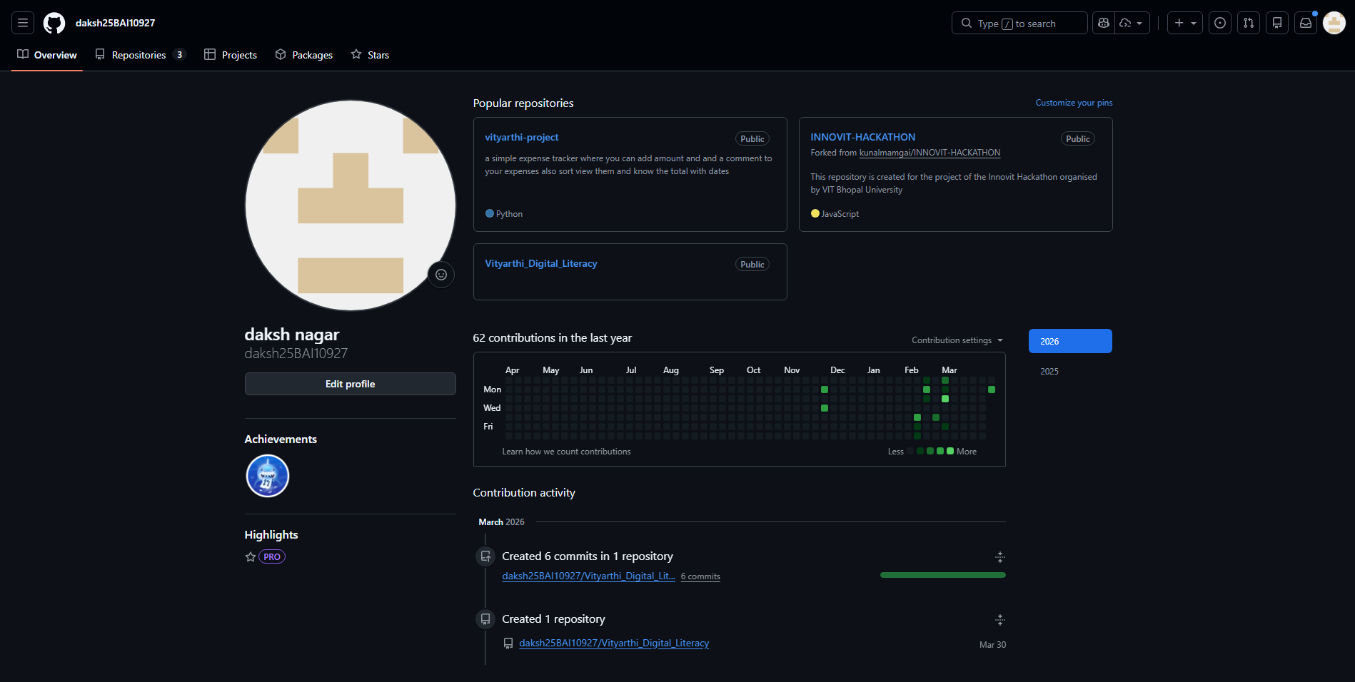
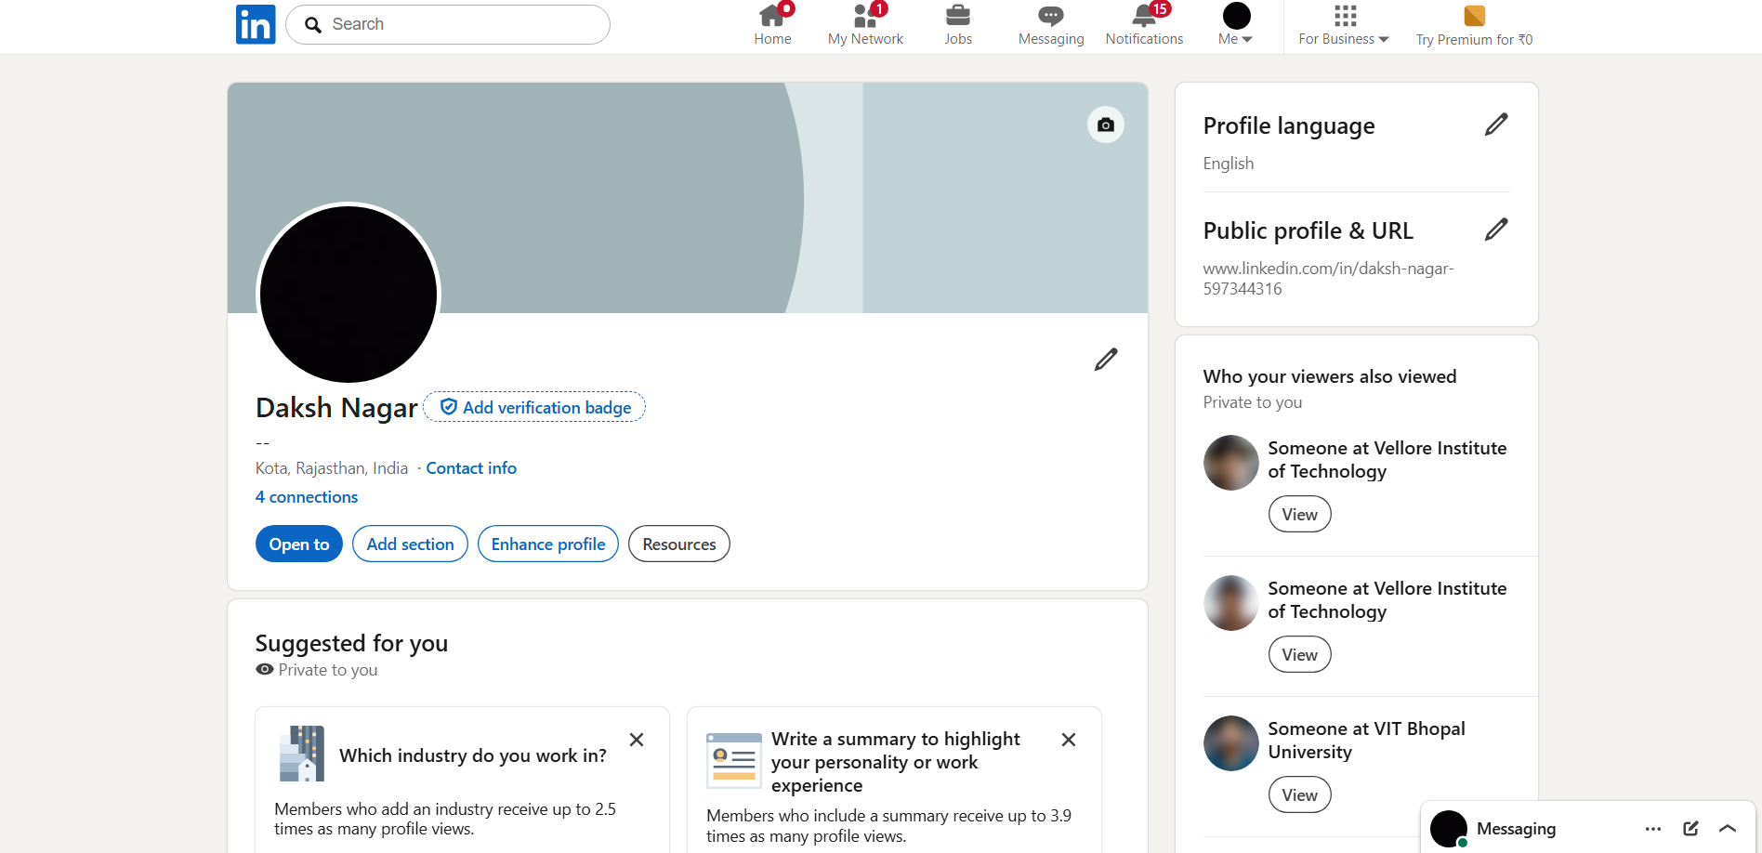

REPORT
Over the past weeks, I created or updated profiles on GitHub, LinkedIn, Kaggle and Stack Overflow to build a strong student digital portfolio. GitHub is a code hosting platform where developers store projects and collaborate using version control; I plan to use it to maintain clean repositories for course assignments, mini projects and personal experiments, making my work visible to recruiters. LinkedIn is a professional networking site used for showcasing education, skills and experience; over the next four years I will keep my profile updated with internships, hackathons and certifications, and connect with peers, seniors and industry professionals. Kaggle is a data science platform with datasets, notebooks and competitions; I aim to use it to practise machine learning, participate in beginner competitions and share notebooks linked from my GitHub. Stack Overflow is a programming Q&A site; I will rely on it to solve coding doubts, learn best practices from existing answers and gradually contribute my own solutions as my expertise grows

